Goodbye, My Son: Marian O'Mahony on coping with the terminal illness of a child
By Maria Moynihan on 08 September 2016

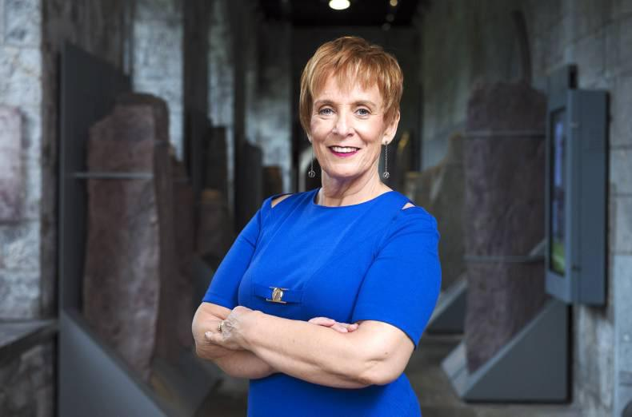
Marian O'Mahony at the launch of Goodbye, My Son. Pictures by Gerard McCarthy.
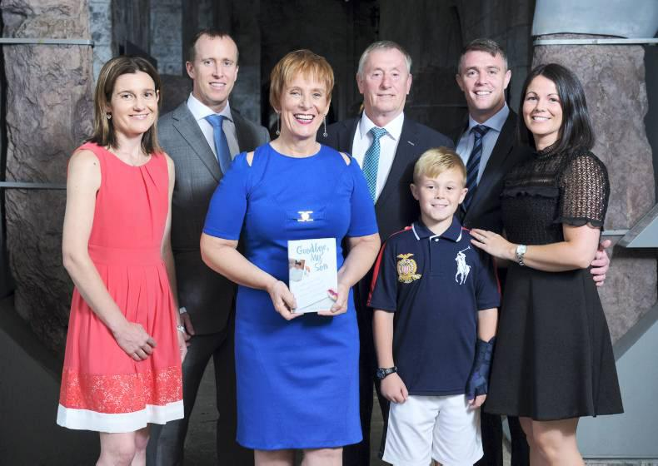

Sinead, John, Marian, John, Brian, Paul and Valerie O'Mahony pictured at the launch of Marian's book, Goodbye, My Son.
- 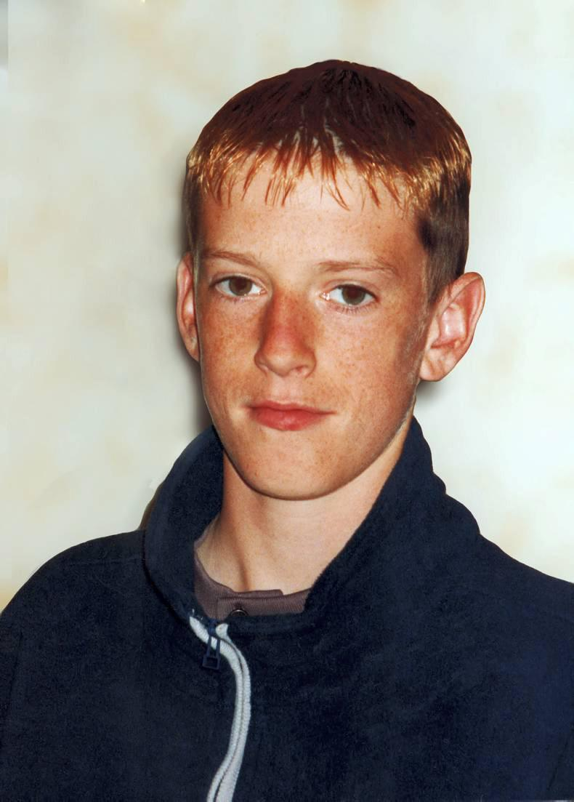
Marian O'Mahony has written Goodbye, My Son as a tribute to her late son, Brian.
In a searingly honest memoir, Cork woman Marian O'Mahony writes about how she coped with the terminal illness of her teenage son Brian - and saying the hardest goodbye, writes Maria Moynihan.

There is a passage in Goodbye, My Son where Marian O’Mahony describes how she sat in her kitchen one day to adjust a black dress she had bought in a rush.
As she was turning up the hem, her 18-year-old son Brian came in but took no notice of his mother’s sewing.
“Those moments seemed so cruel,” she writes simply.
That is because that dress was actually bought for Brian’s funeral, as Marian knew there was simply no way she would be able to “pick out a dress after picking out a coffin”.
And it’s just another moment in her book that hammers home the harsh reality of facing the imminent death of her “six foot tall, handsome, gorgeous son”, having been told he had less than a 1% chance of survival after being diagnosed with leukaemia.
“How do you go into a shop to buy a dress for a funeral for a child that isn’t dead yet?” reflects Marian as she meets with Irish Country Living to talk about the release of her book, 15 years after Brian’s death.
And it’s with searing honesty that Marian shares her experience of how she steered her way through terminal living, bereavement and beyond, in the hope it might help other families in a limbo between life and death with a loved one.
“One day Brian was unconscious and anointed, another day we could go out for a family meal,” says Marian of the rollercoaster she found herself suddenly strapped into – all the while wearing a brave face for her son.
“It was so difficult to pretend all was well when our hearts were breaking.”
Marian is originally from Ballineen in west Cork. She notes that her primary school did not even have electricity when she left, which makes the fact that she has self-published her own book even more remarkable to her.
Working in the environment and sustainability department of ESB Networks, she lives in Bishopstown with her husband John and has three children apart from Brian: John, Paul and Vicky.
She notes that out of the 11 houses in their estate, three families have buried children. Yet absolutely nothing could have prepared her for the transition from busy, working mother to a carer for a sick child – and then, a dying child – within a matter of weeks.
Marian compares Brian to a Jim Carey character: full of fun, football mad and always surrounded by friends. He was midway through his Leaving Cert year in February 2001 when he first started to complain of chest pains that would leave him gasping for breath and trembling.
Diagnosis
Tests revealed there was nothing wrong with his heart, but the pains persisted to the point where he started to lose power in his hands and legs, struggled to eat, needed a straw to drink and could not lift his head from his pillow.
Doctors investigated illnesses included glandular fever and Weil’s disease, with a lumbar puncture eventually scheduled for a Wednesday in mid-March. The news was not good: Brian had leukaemia.
Due to his youth and general health, he was initially given an 85% chance of survival, but despite blood transfusions and chemotherapy, after two weeks, the crippling pain had yet to subside. On 2 April – which was also Marian’s birthday – she was told there had been no response to the treatment. Brian was likely to only survive another week. Two at most.
“I quickly discovered that fear that my child might die was in no way similar to the panic that threatened me when I knew there was no way out,” reflects Marian.“We were trapped.”
In one respect, Brian would prove the doctors wrong, surviving until June.
Marian and John made the decision not to tell him of the final prognosis unless he asked himself, while waiting on a knife’s edge for the latest blood cell count, ever complex care needs and unreal realities like applying for a terminal medical card or buying a dress for the funeral because everything else in Marian’s wardrobe was too colourful.
But as daunting as it must have been, Marian says that she somehow got through that time by drawing on skills she had learned through meditation – or mindfulness in today’s parlance – staying in the moment, not thinking too far ahead and trying to make the most of what time she had left with her son.
“What helped me was believing that I could cope with a moment. What was the alternative?” she asks.
“The totality of my situation was overwhelming. In this one moment, I could find enough strength to breathe. Moment by moment I could get through the hour. Being still. Making the best of it.”
Marian acknowledges that Brian’s own fortitude made it easier to stay strong (“he never complained, which was hard to imagine”) but the book does not shy away from the most sensitive moments in his journey, right up to his passing at home on the morning of 28 June 2001.
Life without Brian
It also deals with Marian’s attempts to adjust to the next chapter: life without Brian. She admits she was unprepared for how “physical” his loss felt. Looking back, believes she was “shaking” for at least a year afterwards. To the fore of her thoughts, however, were her other children.
“They didn’t deserve to lose a brother and a mother,” she says simply.
Just as she tried to cope with Brian’s illness by getting by moment by moment, she focused on the little things she could do to steady the ship and steer the family safely: eating properly, getting enough sleep, returning to work and accepting help when offered.
“I’m very practical – that’s my positive thing –and I’m a big believer in ‘do normal,’” says Marian. “If you don’t know what to do, ‘do normal.’”
As time passed, Marian began to write down the details of Brian’s journey, but it took 15 years before she felt ready to release her story as the book, Goodbye, My Son.
She hopes that by sharing her story, it will help other families in a similar situation, while also advising friends, neighbours and colleagues on how best to offer support.
“Really small things make a difference and I feel that sometimes that’s what puts us off doing things. We feel that we should do something big – especially if there’s a big problem – that we should somehow go down there and make people feel better and really you can’t,” she says
“Do what you’re good at. If you like animals, walk the dog. If you’re good at cutting grass, cut the grass. Because not everybody is good with the words and that’s what puts people off.”
Most importantly though, Goodbye, My Son is a tribute to Brian, who was taken far too soon but will never be forgotten.
“It’s not that I have any particular advice to offer,” says Marian. “We fumbled our way along doing the best we could.
“My only suggestion would be to be present as much as possible, enjoy the moments that can be shared and treasure them forever.”
Goodbye, My Son by Marian O’Mahony is available at stockists including Waterstones, Vibes and Scribes and Veritas (RRP €11.99). For further information or to buy online, visit www.marianomahony.com CL

